How do I 3D print my own phone case?

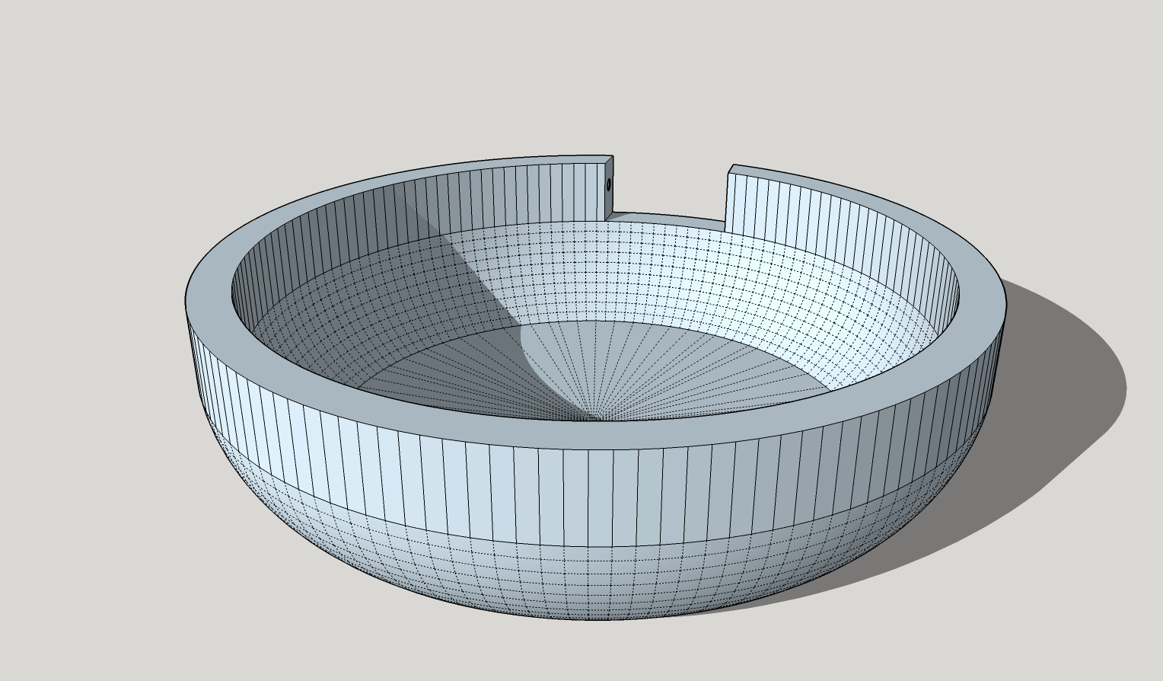

Surprisingly, you do not need a 3D printer to print your own case. Go to [www.3dhubs.com](http://www.3dhubs.com) to find a 3D printer in your neighborhood (or [www.shapeways.com](http://www.shapeways.com) to have it shipped to you), upload your files and pay to have them printed for you.

If you want to print the Cyrcle phone case files you will need to upload the STL format of the files, which can be found here: <https://drive.google.com/drive/folders/0BxuQh7-7eMu_bWhaaU84dVhLMkU?usp=sharing>

If you want to modify the Cyrcle phone case files you will need to

1. install the free version of <http://www.sketchup.com/>,
2. learn how to use Sketchup via the handy videos (takes about 20 minutes?) at <http://www.sketchup.com/learn/videos/58>, and
3. modify the SKP version of the Cyrcle case files which can be found here: <https://drive.google.com/drive/folders/0BxuQh7-7eMu_bWhaaU84dVhLMkU?usp=sharing>

If you want to design your own case from scratch, simply follow steps 1 & 2 from above.

It’s that easy!